How to Play: Pokémon Showdown

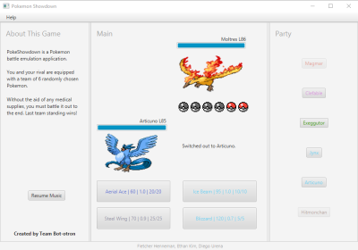

**General:** The object of this game is to make all your opponent’s Pokémon faint - that is, use attacks to lower their health to zero, shown by the health bars. To accomplish this, each Pokémon has four available moves that vary in type, power, and accuracy. The four moves can be found below the user’s Pokémon image and has the move name, followed by its attack power, accuracy, and then PP (the PP determines how many times you can use a move; once the PP hits zero the move is disabled. On rare occasions, if all the PP is used up on all moves the Pokémon will be forced to use an attack called Struggle, which damages the user). Each active Pokémon takes turns battling, which means that the faster Pokémon goes first and executes the selected move. You can use one of your four moves, or switch out if you still have healthy Pokémon available. Each Pokémon has unique stats (attack, defense, speed, health), types, and movesets, which makes every new battle fresh. In the bottom left, the image, name, and level of your active Pokémon is displayed. In the top right, the image, name, and level of your opponents Pokémon is displayed. Each ‘player’ gets six Pokémon, which are randomly generated. Your own six Pokémon are displayed on the right bar, while the opposing player’s Pokémon has six Pokéballs, one for each Pokémon, with the fainted Pokémon having gray Pokéballs.



**Type:** There are currently 18 unique types in the Pokémon world.

Pokémon can have up to two different types which interact differently with different moves. The text color for moves and your party Pokémon corresponds to its type (or only its first type for multi-type Pokémon)

**Move Effectiveness**: Moves have types, just like Pokémon. Moves that have the same type as the Pokémon that is using the move gain a bonus in damage. Different moves have different effectivenesses, shown by the chart. For example, Fighting-type is 2x effective against Rock, which means that the damage dealt will be twice as great, and Fighting is ½x effective against Flying, so the damage dealt will be half as much as normal. However, if a Pokémon has two types, such as Rock/Flying, then a move that has opposite effectivenesses will deal just normal damage (Fighting will only do 1x to a Rock/Flying Pokemon). Finally, some moves are completely ineffective against other types: for example, Ground-type moves do zero damage to a Flying-type pokemon, regardless of what the Flying-type pokemon’s second typing is. Occasionally, there is a random chance that a critical hit will occur, multiplying damage by 2x.



